KLR Wine Filter
USER MANUAL

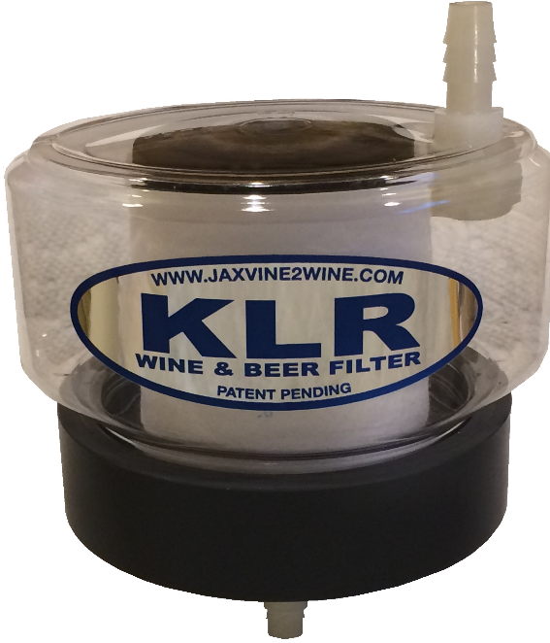
www.klrfilter.com

Introduction

Thanks for buying this product! The base was hand-machined out of solid PVC plastic, which is highly durable. The plastic filter body creates the perfect method for sealing the unit while pressing the ends of the filter cartridge, forcing your wine to go through the filter cartridge for great results.
This kit can also be used to filter beer by using larger micron filters, which are available at klrfilter.com. The wine kit came with a 1 and 5 micron filter, which are normally used for filter wines.
Additional directions and instructional videos are available online at klrfilter.com.

Warranty
The KLR Filter is guaranteed against defects for 30 days after the date of purchase. If the filter fails to perform as advertised within those 30 days, simply return everything undamaged for a full refund.

Parts and Filter Cartridges
Replacement parts and filter cartridge replacements are available at klrfilter.com. Filter cartridges come in 1, 5, 10, 20 and 50-micron filtration capabilities. All filter cartridges fit this filter kit.

Comments/Questions
Please use our website to send us questions or comments. Click on the Contact Us tab at the top of the home page.

Uses
1 and 5 micron filters are suitable for filtering home wine or other relatively Beer filtering uses 10, 20 or 50-micron filter cartridges. All KLR filter cartridges fit the KLR Filter.
Filtering typically occurs after the wine has completed initial clarification. See the Web site for general filtering schedules.

List of Cautions
- Disassembly of the fitting on the filter body voids the warranty. If the top body inflow fitting is removed, please test it for leaks prior to filtering a precious batch of wine.
- Use only for filtering home brews. This unit is not intended for filtering sprits and other liquids.
- Do not pressurize the filter body. This product is designed for gravity feed filtering only.
- If you dissemble the filter, keep small parts out of reach of children and pets.
- Use only as designed and per these instructions.
- Clean after each use. Never use detergent-based soap on any brewing equipment.
- Prior to use, rinse the inside and outside of the filter unit with a potassium metabisulfite solution as you would with any home brew equipment.
- Do not store liquids in the filter when not in use. It is recommended that you leave the unit apart to air dry between uses.
- Filter cartridges are not reusable. Discard after each batch of home brew has been filtered.
- Use only one filter cartridge per batch of brew to eliminate the potential for cross-contamination.
- Do not leave filters exposed to open air for long periods. They might pick up germs and microbes that could negatively affect your results.
- The maximum amount of wine that has been test filtered through a single filter cartridge is 20 gallons. It is recommended that you replace the filter cartridge if filtering more than 20 gallons of wine.

KLR Filter Parts and Diagram
The diagram below provides a view of the parts provided in your filter kit shows you how the filter is assembled. Please see the videos on our Web site for more tips and instructions for using the KLR wine filter.
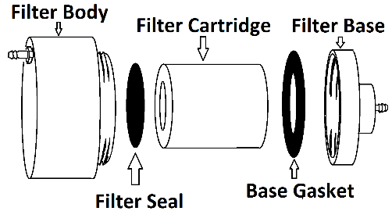
Filter Body
The filter body is the clear plastic part with a barbed fitting to one side.
NOTE: The barbed fitting is canted at a slight angle on purpose. Removing or straitening the body barb fitting voids the warranty and makes you upset for not reading these directions and potentially ruining a great filter system!
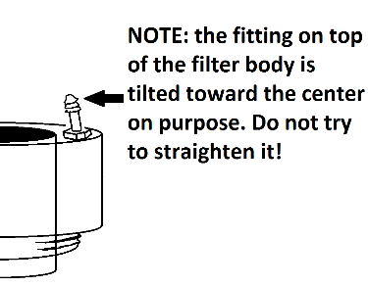
Filter Seal
The filter seal is a solid black rubber disk. It sits on top of the filter cartridge element when assembling to provide a seal between the filter cartridge and the filter body. You received an extra one of these in your filter kit. Wash the rubber gaskets and seals prior to use as they may have talc on them.
Filter Cartridge
The filter cartridge is a cylindrical filter made from spun plastic filaments. There are two sizes of filters in the wine filter kit. The filter marked 5 micron is a course filter, and is used for the first or initial filtering of your wine. The filter marked in 1 micron is used for final filtering of your wine.
NOTE: There may be loose fibers on the filters and in the center hole. Inspect and rinse prior to use. If loose material can be plucked off with your fingers, please do so. We air cleaned them prior to shipping but please look them over before use!
Base Gasket
The base gasket is a rubber ring that fits snugly into the filter base, and a spare one was provided. Wash completely before use as they may have talc on them.
Filter Base
The filter base is the heavy piece of gray PVC with a threaded barb on the bottom of it. This is the hand-machined piece of the kit.

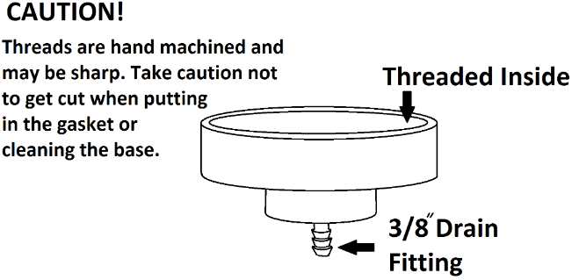

Directions for Use

1. While the filter base and filter body are apart wash all parts with sanitizer or a brew equipment cleaning solution. Any solution you use to clean brewing equipment will also work for this filter unit.
NOTE: Never use detergents, dish soaps or other types of common soaps to clean the KLR Filter or any of your brewing equipment. These soaps tend to leave residues that adversely impact the quality, smell, and taste of your home brews.
2. Rinse the KLR Filter base gasket, filter seal, filter body and filter base with pure water. Then lightly spray with, or rinse in, a potassium metabisulfite solution.
NOTE: Chlorine, which is commonly found in tap water, imparts unwanted flavors and aromas to home brews. Minimize the use of tap water for rinsing your brewing equipment or for adding water to top off brews.
3. Insert the base gasket into the filter base. It fits under the threads and there may be a small bump when you have pushed it in all around. Simply work it into the recess until it is smooth and flush with the filter base.

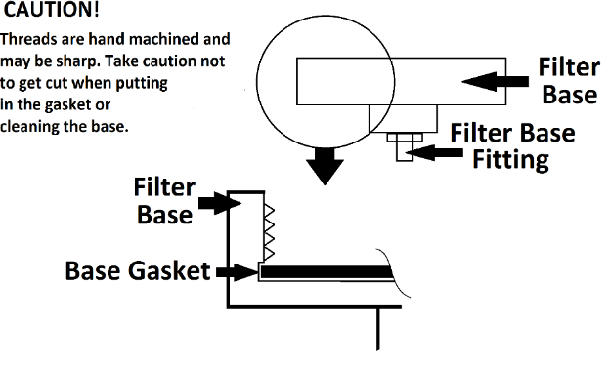

4. Remove a new filter cartridge from the protective wrapper. Inspect it for any lose particles that may have remained after we air cleaned it. Remove any loose bits of filter cartridge with your fingers. Rinse it off.
5. Spray the entire filter cartridge with a potassium metabisulfite solution to minimize the potential for inadvertently introducing contaminants to your wine.
6. Place the filter cartridge inside the filter base within the circular slot in the center of the base.
7. Place the filter seal on top of the filter.

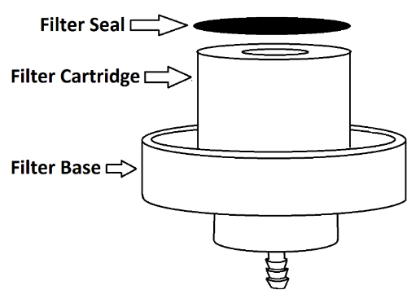
8. Screw the filter body onto the base while keeping the filter seal centered on the filter cartridge (see the diagram on page 6 and the manual cover page picture). DO NOT OVER TIGHTEN!
NOTE: The filter seal can be slightly off-center. The main purpose of the seal is to cover the center hole of the filter cartridge. This provides a seal to force liquid through the filter cartridge walls.
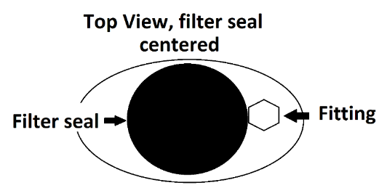

This is okay, as is the one in the image below:

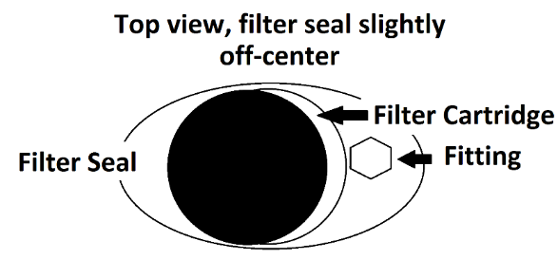

In the image below, the filter seal is so far over that it allows part of the filter cartridge hole to show. THIS WILL NOT WORK! It will allow your wine to go through the middle of the cartridge without being filtered.
NOT GOOD!
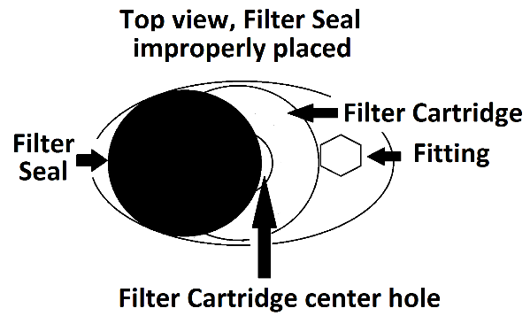
9. Hand tighten only. Ensure the base and body are firmly attached to each other. This will prevent your brew from leaking around the base.
10. Look through the top of the filter body to ensure the filter seal covers the center hole of the filter cartridge.
11. Connect a 3/8” tube (not supplied) to the bottom of the filter base fitting for the receiving carboy.
NOTE: This unit relies on gravity to function correctly. It is not intended for pressurized use. It is advised you only push the hoses over the first or second ridge of the fitting. This will make removal easier.

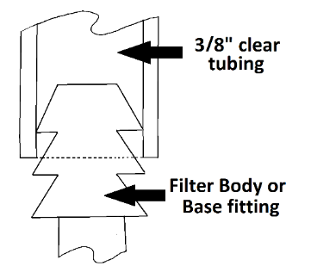

12. Set the filter unit on top of the carboy and position the carboy to receive the filtered wine from the first source (see the next diagram).
13. Connect the top 3/8” tubing (not supplied) to the filter body fitting and the siphon.

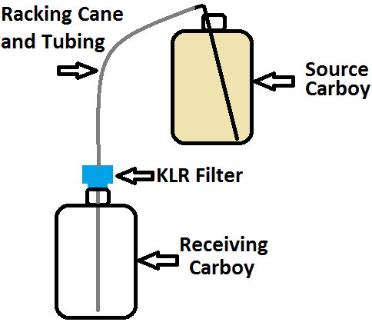

14. If your racking cane (or siphon) is too small for the 3/8” tubing, simply cut a small piece of larger hose and use it as the connector.
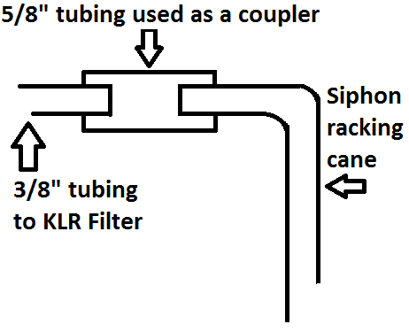

TIP: I finally figured out that each successively smaller or larger standard clear plastic tubing you find in your supply shop fits inside the next higher or lower size. For instance, the 1/4” inner diameter tubing fits perfectly into the 3/8” inner diameter tubing. The 3/8” inner diameter tubing fits perfectly into the ½ inner diameter tubing. You can use them to adjust the tubing end size to fit whatever you need to connect to without buying fancy adapters. For those of you who already knew this…please skip this tip.
15. Use your racking cane or siphon apparatus to start the flow of liquid to the KLR Filter unit.
NOTE: Some folks simply suck on the clear plastic tubing to get the flow started. If you do this, try not to leave a large air bubble pocket at the top. It will cause the filtering to go slowly. If no air is in the tubing to the filter, the filtering goes much faster.
16. Once liquid is flowing to the filter, monitor it to make sure filtering is working properly. Some beers are extremely heavy with sediment, requiring a change of filter cartridges. This is due to the presence of hops and malt sediments.
17. Once filtering is complete remove the filter unit from the top of the carboy.
18. Disassemble the KLR Filter.
NOTE: If it is difficult to unscrew the filter body from the filter base, run some hot water around the joint where they screw together. It will loosen up enough to disassemble.
19. Discard the filter cartridge (you can put it in the recycle bin!).
20. Clean the filter unit as described above.
21. Dry the unit and store in a plastic bag or other protective enclosure until next use.
For additional information, instructional videos, replacement filter cartridges, or replacement parts visit:

klrfilter.com

